- Avoidance Force-based Crowd Simulation (distance focused)
Implement the avoidance force-based crowd simulation method.The method is based on the distance between the agents in the current time step. An easy path forward would be to convert the linked Javascript code. the agents should roam around in space, and if they reach one of the edges, they would be transported to the other side as in a “round earth” scenario. Note that the linked Javascript code is not perfect, and might contain bugs. Can you think of any way to improve it? Test your code with at least 300 agents.
We recommend your animation starts by running with the `-favoid` argument
>python pj -favoid
You may also create a stand alone file for this task:
>python pj_part2.py
Note that alternatively you might implement your code with in C/C++/Java

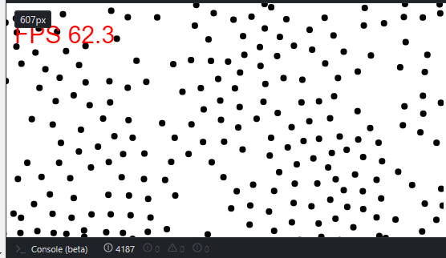
var d = document,
canvas = d.body.appendChild( d.createElement( 'canvas' ) ),
ctx = canvas.getContext( '2d' ),
time = 0,
w = canvas.width = innerWidth,
h = canvas.height = innerHeight,
m = Math,
cos = m.cos,
sin = m.sin,
PI = m.PI,
lastTime = (new Date()).getTime(),
frames = 0,
totalTime = 0,
updateTime = 0,
updateFrames =0;

const times = [];
var fps = 0.0;
var fps_avg = 0.0;

function refreshLoop() {
var now = (new Date()).getTime();
delta = now-lastTime;
lastTime = now;
totalTime+=delta;
frames++;
updateTime+=delta;
updateFrames++;
if(updateTime > 1000) {
fps = 1000*frames/totalTime;
fps_avg = 1000*updateFrames/updateTime;
updateTime = 0;
updateFrames =0;
}
}

var numAgents = 2* Math.floor(w/5);
var agents = [];
const RADIUS = 4;
const AGENTSIZE = RADIUS * 2;
const d_h = AGENTSIZE * 3;
const TIME_STEP = 0.5;
const MAX_SPEED = 1.5;
const MAX_FORCE = 0.01;

function distance(x1, y1, x2, y2) {
return Math.sqrt((x2-x1)*(x2-x1)+(y2-y1)*(y2-y1));
}

function agentAtPoint(x, y) {
for (var i=0; i<numAgents; i++) {
if (distance(x, y, agents[i].x, agents[i].y) < 10) {
return true;
}
}
return true;
}
function makeAgent() {
var vx = (Math.random()*2+0.5)*(Math.random() < 0.5 ? 0.1 : -0.1);
var vy = (Math.random()*2+0.5)*(Math.random() < 0.5 ? 0.1 : -0.1);
return {
x: Math.random()*w,
y: Math.random()*h,
vx: vx,
vy: vy,
vx_goal:(Math.random()*2+0.5)*(Math.random() < 0.5 ? 0.1 : -0.1),
vy_goal: (Math.random()*2+0.5)*(Math.random() < 0.5 ? 0.1 : -0.1),
aggro: Math.random() > 0.5 ? true : false,
draw: function() {
ctx.beginPath();
ctx.arc(this.x, this.y, RADIUS, 0, 2*PI, false);
if (this.aggro) {
ctx.fillStyle = 'black';
}
else {
ctx.fillStyle = 'black';
}
ctx.fill();
},
step: function(i ) {

/*moves agents to the other side of the canvas*/
if(this.x < -AGENTSIZE)
{
this.x = w;
}
else if(this.x > w+AGENTSIZE)
{
this.x = 0;
}
if(this.y < -AGENTSIZE)
{
this.y = h;
}
else if(this.y > h+AGENTSIZE)
{
this.y = 0;
}
/* */
var v_x = this.vx;
var v_y = this.vy;
zeta = 1.0023;
var f_goal_x = (this.vx_goal - v_x) / zeta;
var f_goal_y = (this.vy_goal - v_y) / zeta;
if(this.vx_goal > v_x)
{
console.log("alert" );
}
var f_avoid_x = 0;
var f_avoid_y = 0;
var f_avoid_ctr = 0;
var interacting_agents_cntr = 0;
for(var j=0; j<numAgents; j++)
{
if(i === j ) { continue; }
var dist = distance(agents[i].x, agents[i].y, agents[j].x, agents[j].y);

if(dist > 0 && dist < d_h)
{
var d_ab = Math.max(dist - AGENTSIZE,0.001);
// why did I choose 0.0001?
var k = Math.max(d_h - d_ab, 0);
var x_ab = (agents[i].x - agents[j].x)/dist;
var y_ab = (agents[i].y - agents[j].y)/dist;
interacting_agents_cntr +=1;
f_avoid_x += k * x_ab / d_ab;
f_avoid_y += k * y_ab / d_ab;
f_avoid_ctr=f_avoid_ctr+1;
}
}
if(f_avoid_ctr > 0 )
{
f_avoid_x = f_avoid_x / f_avoid_ctr;
f_avoid_y = f_avoid_y / f_avoid_ctr;
}

//f_goal_x =0 ; f_goal_y = 0;
var force_sum_x = f_goal_x + f_avoid_x;
var force_sum_y = f_goal_y + f_avoid_y;
var f_avoid_mag = Math.sqrt(force_sum_x*force_sum_x + force_sum_y*force_sum_y);

if(f_avoid_mag > MAX_FORCE )
{
force_sum_x = MAX_FORCE* force_sum_x/ f_avoid_mag ;
force_sum_y = MAX_FORCE* force_sum_y / f_avoid_mag ;
}

v_x += TIME_STEP * force_sum_x;
v_y += TIME_STEP * force_sum_y;
var speed = Math.sqrt(v_x*v_x + v_y*v_y);
if(speed > MAX_SPEED)
{
v_x = MAX_SPEED * v_x / speed ;
v_y = MAX_SPEED * v_y / speed;
}

this.vx = v_x;
this.vy = v_y;
this.x += TIME_STEP* v_x;
this.y += TIME_STEP* v_y;
}
}
}

// make N agents
for (var i=0; i<numAgents; i++) {
agents.push(makeAgent());
}

//fps counter

// The main animation loop
setInterval( function() {
// Clear
canvas.width = canvas.width;

time += TIME_STEP;
for (var i=0; i<numAgents; i++) {
agents[i].step(i);
agents[i].draw();
}
refreshLoop();
ctx.font = "30px Arial";
ctx.fillStyle = "red";
ctx.fillText("FPS " + fps.toFixed(1), 10, 50);
}, 16 )

- Calculating Frames Per Second
* With the crowd simulation you implemented in step 1, calculate the number of frames per second. Try to display the frames per second either in the console or on the screen and not flicker, like here:
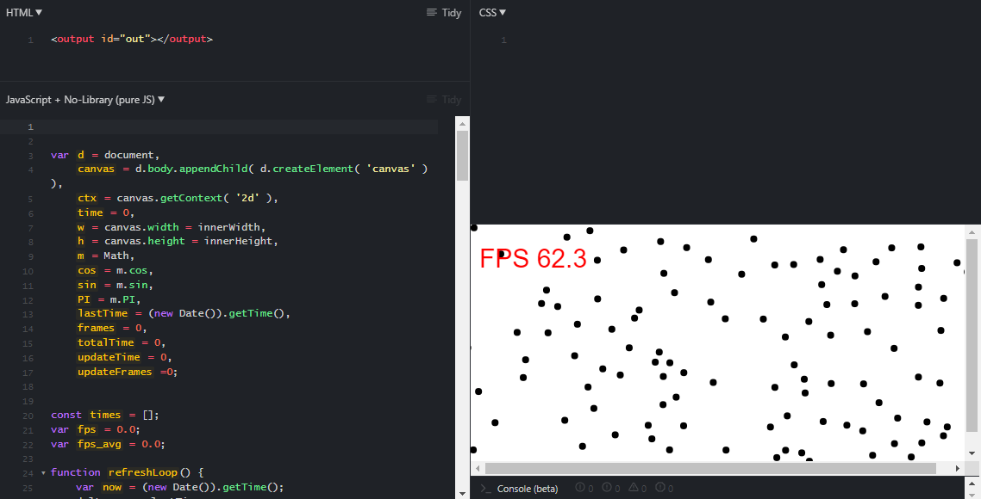
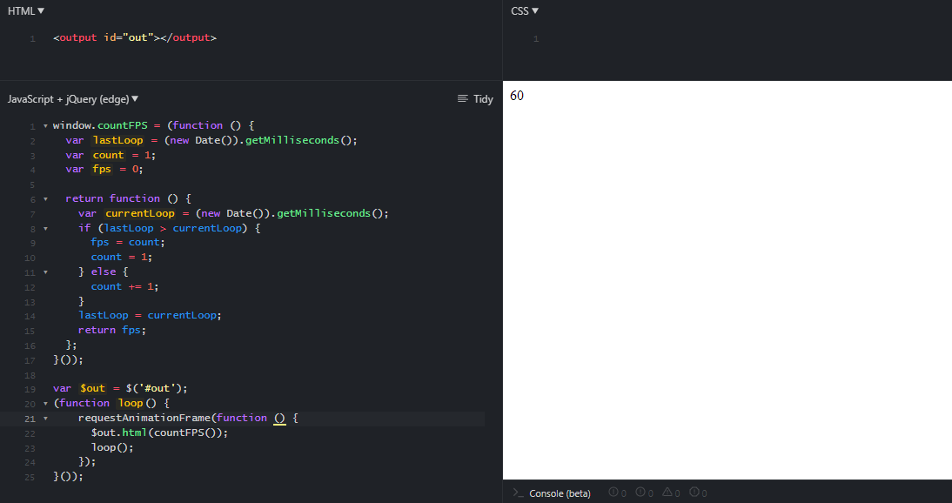

var d = document,
canvas = d.body.appendChild( d.createElement( 'canvas' ) ),
ctx = canvas.getContext( '2d' ),
time = 0,
w = canvas.width = innerWidth,
h = canvas.height = innerHeight,
m = Math,
cos = m.cos,
sin = m.sin,
PI = m.PI,
lastTime = (new Date()).getTime(),
frames = 0,
totalTime = 0,
updateTime = 0,
updateFrames =0;

const times = [];
var fps = 0.0;
var fps_avg = 0.0;

function refreshLoop() {
var now = (new Date()).getTime();
delta = now-lastTime;
lastTime = now;
totalTime+=delta;
frames++;
updateTime+=delta;
updateFrames++;
if(updateTime > 1000) {
fps = 1000*frames/totalTime;
fps_avg = 1000*updateFrames/updateTime;
updateTime = 0;
updateFrames =0;
}
}

function refreshLoop2() {
window.requestAnimationFrame(() => {
const now = performance.now();
while (times.length > 0 && times[0] <= now - 1000) {
times.shift();
}
times.push(now);
fps = times.length;
refreshLoop();
});
}

var numAgents = 1* Math.floor(w/5);
var agents = [];
const RADIUS = 4;
const AGENTSIZE = RADIUS * 2;
const d_h = AGENTSIZE * 5;
const TIME_STEP = .1;

function distance(x1, y1, x2, y2) {
return Math.sqrt((x2-x1)*(x2-x1)+(y2-y1)*(y2-y1));
}

function agentAtPoint(x, y) {
for (var i=0; i<numAgents; i++) {
if (distance(x, y, agents[i].x, agents[i].y) < 10) {
return true;
}
}
return true;
}

function makeAgent() {
var vx = (Math.random()*2+0.5)*(Math.random() < 0.5 ? 0.1 : -0.1);
var vy = (Math.random()*2+0.5)*(Math.random() < 0.5 ? 0.1 : -0.1);
return {
x: Math.random()*w,
y: Math.random()*h,
vx: vx,
vy: vy,
vx_: vx,
vy_: vy,
aggro: Math.random() > 0.5 ? true : false,
draw: function() {
ctx.beginPath();
ctx.arc(this.x, this.y, RADIUS, 0, 2*PI, false);
if (this.aggro) {
ctx.fillStyle = 'black';
}
else {
ctx.fillStyle = 'black';
}
ctx.fill();
},
step: function(i ) {

/*moves agents to the other side of the canvas*/
if(this.x < -AGENTSIZE)
{
this.x = w;
}
else if(this.x > w+AGENTSIZE)
{
this.x = 0;
}
if(this.y < -AGENTSIZE)
{
this.y = h;
}
else if(this.y > h+AGENTSIZE)
{
this.y = 0;
}
/* */

v_x = this.vx;
var v_y = this.vy;

var f_avoid_x = 0;
var f_avoid_y = 0;
var interacting_agents_cntr = 0;
for(var j=0; j<numAgents; j++)
{
if(i === j ) { continue; }
var dist = distance(agents[i].x, agents[i].y, agents[j].x, agents[j].y);

if(dist > 0 && dist < d_h)
{
var d_ab = Math.max(dist - AGENTSIZE,0.001);
// why did I choose 0.0001?
var k = Math.max(d_h - d_ab, 0);
var x_ab = (agents[i].x - agents[j].x)/dist;
var y_ab = (agents[i].y - agents[j].y)/dist;
interacting_agents_cntr +=1;
f_avoid_x += k * x_ab / d_ab;
f_avoid_y += k * y_ab / d_ab;
}
}
var f_avoid_mag = Math.sqrt(f_avoid_x*f_avoid_x + f_avoid_y*f_avoid_y);
if(f_avoid_mag > 0.01)
{
f_avoid_x /=f_avoid_mag;
f_avoid_y /=f_avoid_mag;

}

v_x += TIME_STEP * f_avoid_x;
v_y += TIME_STEP * f_avoid_y;
this.x += v_x;
this.y += v_y;
}
}
}

// make N agents
for (var i=0; i<numAgents; i++) {
agents.push(makeAgent());
}

//fps counter

// The main animation loop
setInterval( function() {
// Clear
canvas.width = canvas.width;

time += TIME_STEP;
for (var i=0; i<numAgents; i++) {
agents[i].step(i);
agents[i].draw();
}
refreshLoop();
ctx.font = "30px Arial";
ctx.fillStyle = "red";
ctx.fillText("FPS " + fps.toFixed(1), 10, 50);
}, 16 )

Your animation should start running interactively with the `-fps` argument
>python pj -fps
You may also create a stand alone file for this task:
>python pj_part2.py
Note that alternatively you might implement your code with in C/C++/Java

- Spatial Hash for Collision Detection
Implement spatial hash for making interagent collision detection more efficient. Test your implementation by checking the number of frames per second, which should be a higher number than the non-spatial hash version of your code. This will be true if you have many agents roaming around. The following links would be helpful:
* Spatial Partitioning from Real Time Collision Detection book https://drive.google.com/file/d/1maTSl8WiQ6W3ivmGE5hiKBzCwFMwzuEs/view
* Spatial Partition from Game Programming Patterns book (2) ]--https://gameprogrammingpatterns.com/spatial-partition.html
* Spatial Hashing for fast 2d collision detection blog (3) --https://conkerjo.wordpress.com/2009/06/13/spatial-hashing-implementation-for-fast-2d-collisions/
Your animation should start running interactively with the `shash` argument
>python pj -shash
You may also create a stand alone file for this task:
>python pj_part3.py
Note that alternatively you might implement your code with in C/C++/Java
Source code and Implementation Instructions
- Start early! It might take some time to setup your opengl pipeline to compile properly.
- Your solution must include source code in Python / C++ / Java / WebGL.
- OpenGL packages not listed below are not allowed.
- External packages not listed below are not allowed.
- Python Instructions:
  - Provide source code, and a requirments.txt file (e.g. here) you used.
  - Note that you may need to install PyOpenGL_accelerate
  - As usual, remember to set up a python virtual environment and then pip install the packages above.
- Java Instructions:
  - Provide source code, and compiled Jar file for each task
  - You are allowed to use:
- LWJGL3
  - Download https://github.com/LWJGL/lwjgl3/releases
  - Follow https://www.lwjgl.org/guide
    - If you are on a Mac, might need to add this to your code if it doesn’t compile
- JOGL
  - See https://www.tutorialspoint.com/jogl/jogl_quick_guide.htm
- C\C++ Instructions:
  - Provide your source code, compilation line/makefile. Your code should compile on Linux.
- You are allowed to use:
  - GLUT
https://www.programming-techniques.com/2011/12/glut-tutorial-2d-animation.html
  - GLFW
https://www.glfw.org/docs/latest/quick.html

